Probabilistic Reversal Learning BJA004: Set up and Standard Operating Procedure
Important note! When leaving H39 always check all water bottles are facing the right way.
Setting Up Checklist
- Between 8:30-9:15am remove food from hoppers and put into large tupperware on the top of the cage shelf. Flip the ‘free food’ labels to ‘food restricted’. Write “Food removed BJA004” and the time in the H39 log.
- [Monday Only] Weigh mice (see help 1.0)
Running The First Cohort
Setting up this part often takes about half an hour. The first cohort should be run at around 1:30-2:00.
- Turn on the chambers, cameras and computers (see help 2.0)
- Launch K-limbic from the second monitor in the outer room (mouse and keyboard are labelled blue). The computer code is 8568, and the K-limbic password is “klimbic”.
- Replace metal trays and grids.
- Flush the tubing with water and then prime with milkshake (see help 3.0). Remove milkshake in the magazine using paper towels.
- Check whether there are any notes from the previous session in the notebook, and load the session for the first cohort of mice (see help 4.0 and 8.0). All mice are currently on PRL – Constant, other than #5 (Must Initiate), #7 and #8 (Reversal Training).
- Bring through all mice to run from H39. Mouse #3 and #4 are caged together but run separately and so #3 will need to be put in the transport cage (blue label, stored in H39). Trollies can be found in H45.
- Put mice in chambers and click “start session” for each mouse. You can do put two or three in at once before hitting start but try not to leave the mice in the chambers for too long with nothing to do. Be careful to set them up correctly as they are not marked!
- Watch mice on the monitors to ensure the task has started and is working as expected.
If you are leaving the ASU while a session is running make sure you know what time the first mouse is due to finish and be back before then.
Running the Second Cohort
- Return the first cohort of mice to H39. Make sure they all have access to water!
- Note down the number of correct and incorrect trials. If #5,#7 or #8 finishes earlier than 1 hour then make a note of the time (and let me know!).
- Wash, dry and replace the metal trays
End of the Day Checklist
- Return all mice to H39 and note down the results from the final session.
- Remove milkshake bottles, trays and grids from the boxes and wash in the sink with detergent. Make sure to keep the screws from the grids on top of each box.
- Clean the bottom of the chambers.
- [!Unless Thursday] Clean the end of the tubing and flush twice with hot water (see help 3.0). Dry the magazine.
- Turn off the chambers, cameras and computers (see help 2.0)
- Return food to mice, flip ‘food restricted labels’ and update the H39 log. It is good to feed mice around two hours after task completion to prevent them from associating end of task with being fed.
- [Wednesday Only] Change mouse cages and record in the H39 log (see help 6.0)
[Thursday only] Clean and replace pump tubing (see help 7.0)
[Friday Only] Weigh mice (see help 1.0)
- Final checks; double check all mice have access to food and water, that the H39 log is up to date and that any open milkshake is labelled and in the fridge.

Help
- Weighing Mice
  - Scales are kept in H16.
  - Weigh mice in cardboard tubes, subtracting the weight of the tube using the tare function and stabilizing the tube using two wooden blocks.
  - If the scale runs out of battery there us a USB-C in H16 which can be plugged into the computer
- Layout of the room and turning everything on
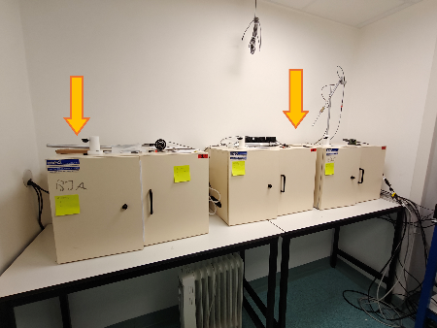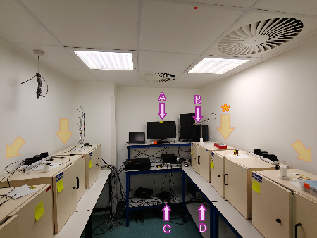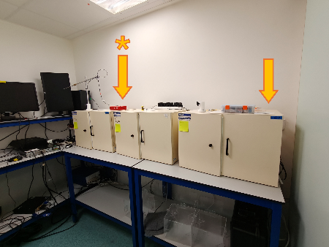
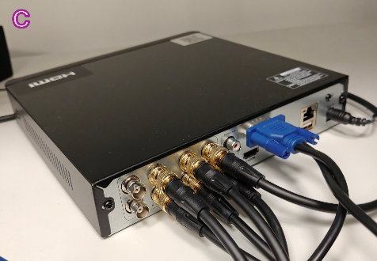 | 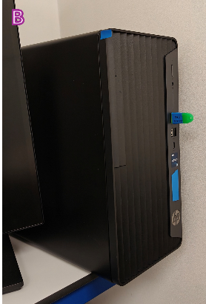 | 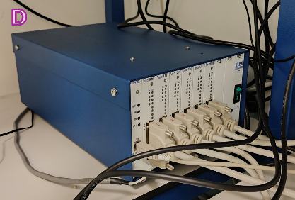
Fig 1. Layout of room Wall switches are indicated by orange arrows. *Wall switch linked to camera integration box. A) Monitor for camera displays B) Computer running K-limbic, linked to blue monitor/mouse & keyboard in outer room. Green drive is key for K-limbic. C) Camera integration D) Central thing

  - Turn on all switches at the wall. Leave the switch linked to the camera integration (Fig.1*) for last as turning on the cameras themselves afterwards can cause the order of the display to be scrambled.
  - Turn on the blue computer (Fig1.B)
  - Check the central thing is on (Fig1.D)
  - Close the pop up on the camera monitor (Fig1.A). If the mouse isn’t working, unplug and re-plug it from the box (Fig1.C). If the display isn’t showing the six boxes, make sure the blue HDMI is plugged into the box.

- Priming tubing and testing chambers
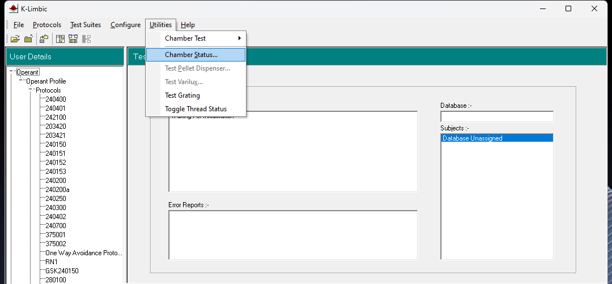
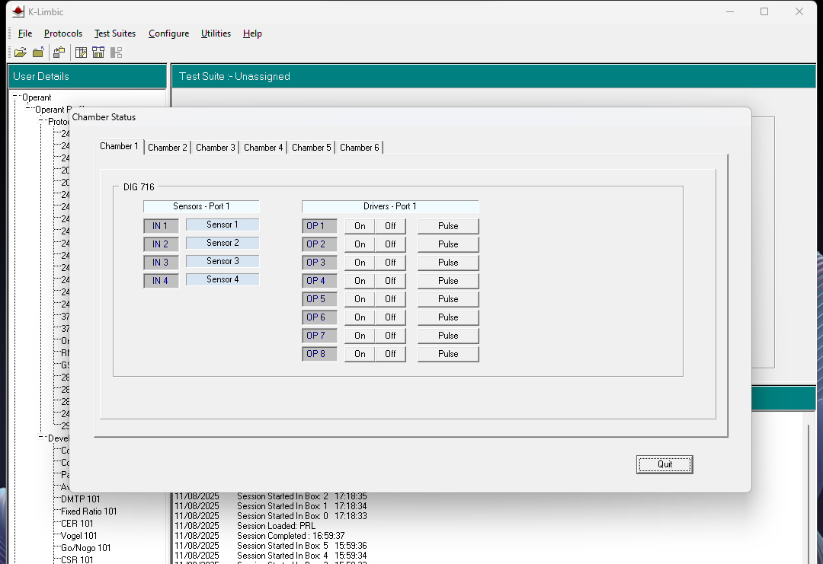
Fig 2. Chamber testing Navigate through boxes 1-6 using tabs at the top. Test operations using ‘on/off’ or ‘pulse’ buttons. Pulse runs for 2 seconds.
  - Fill bottles with warm water, put into boxes and insert open end of tube
  - On K-limbic go to Utilities>Chamber Status (fig. 1).
  - For each chamber;
    - Turn on the left (“op 1”), right (“op 2”) and magazine (“op 3”) lights by clicking.
    - Check that the tone (“op 5”), white noise (“op 6”) and high tone (“op 7”) are working.
    - Rinse line with water by turning on “op 8” for ~5 seconds.
  - Inspect boxes to check all lights are on and dry water with paper towels
  - Prime tubing with milkshake. Milkshake is stored in the cupboards in H16. Generally, half a bottle is used per day, and open milkshake should be labelled and stored in the fridge in H?? Contact Johan if there are fewer than five bottles remaining. Replace the warm water with milkshake (~2cm deep/ bottle) and run through the tubing (as above). Check milkshake has entered the magazine in all boxes and dry with paper towel.

- Loading a session
  - Go to File>Load Test Suite (3a) and choose 210453mPRL (3b)
  - Go to Session>Load Session (3c) and click ‘ok’ (3d)
  - The programme will show boxes 1-6 consecutively. For each box select the mouse, or choose leave box empty (3e) and then select the correct trial stage (3f).
a | 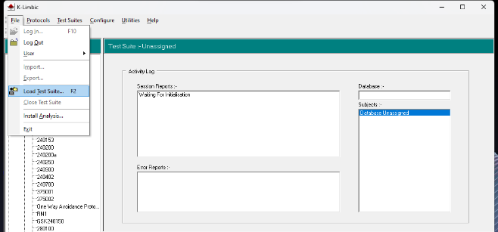 | d | 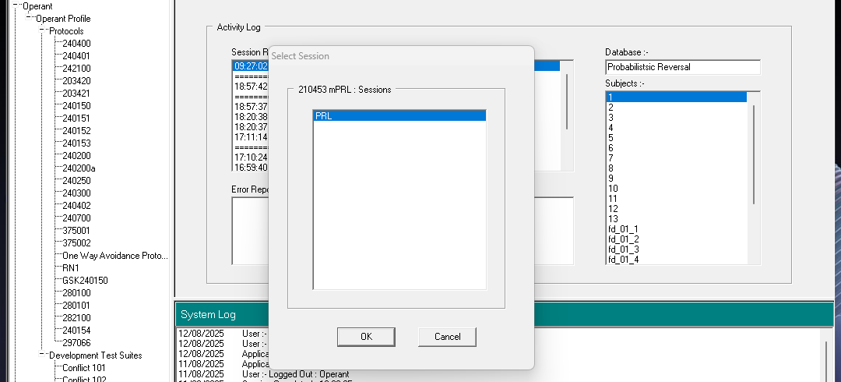
b | 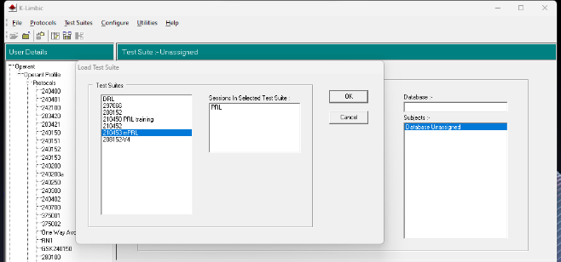 | e | 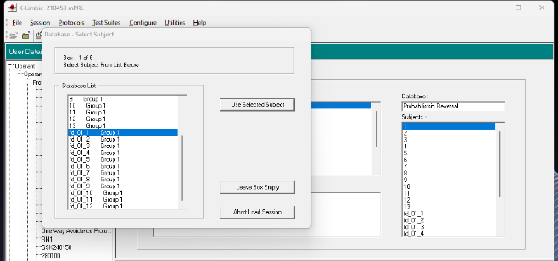
c | 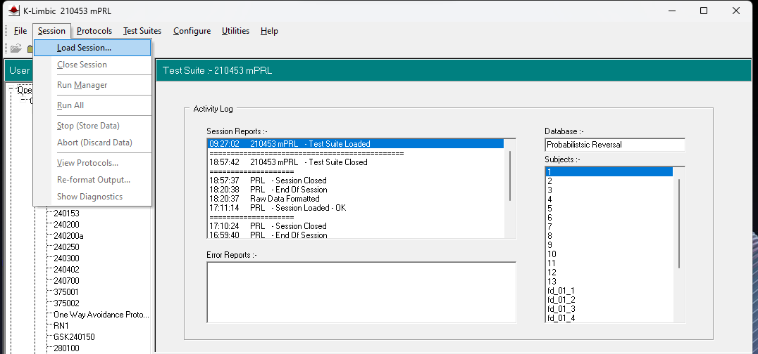 | f | 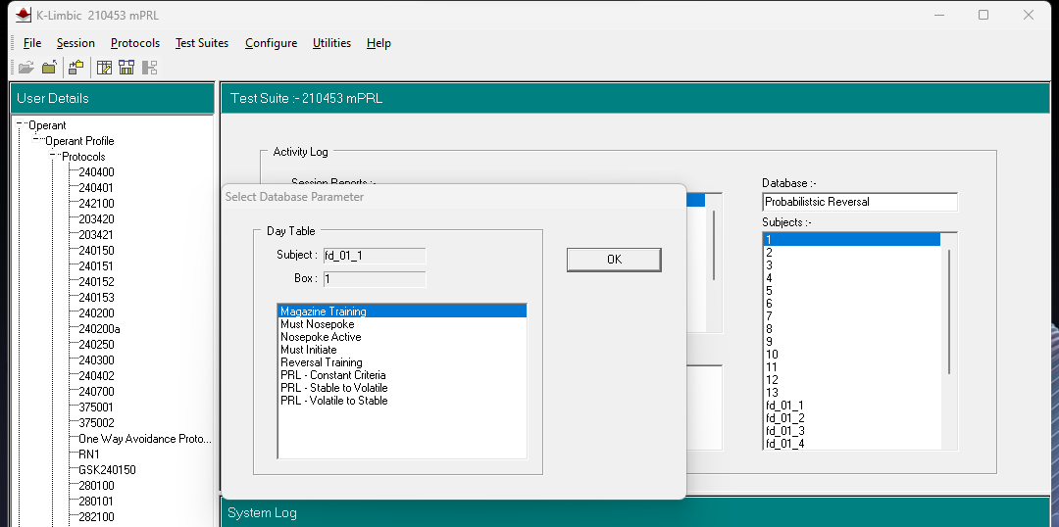
Fig 3. Loading a session

- Weighing out food & feeding mice
- Cleaning cages
- Changing the tubing
- Layout of the chamber
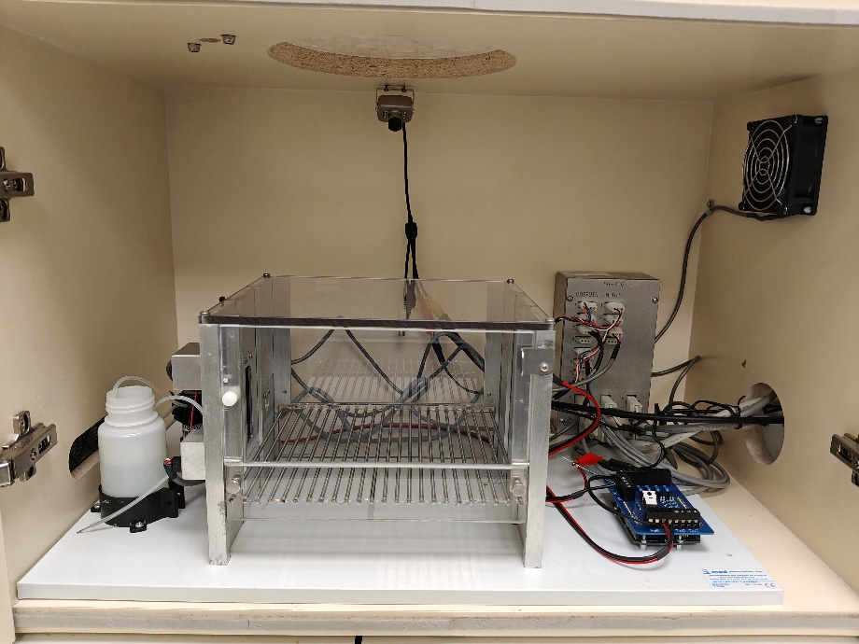
Fig 4. Layout of the chamber

- Structure of the PRL task
All sessions last 1 hour. One trial is concluded by the collection of the reward; 7ul strawberry yazoo.
 | Stage | Description | Criteria
1 | Magazine Training |  | 100 trials
2 | Nosepoke |  | 100 trials
3 | Active Nosepoke |  | 100 trials & 80% Accuracy
4 | Must Initiate |  | 100 trials & 80% Accuracy
5 | Reversal Training  Both lights 100% and 0% | 2x left 2 right | 120 trials
6 | Probabilistic Reversal Training |  | N/A

I have been setting up at 2:00pm for a 2:30pm start, but that will mean leaving at around 6:00pm. I am planning to start running my mice earlier so I can be supervised for injections, but if you want to run them at 2:30 that is still fine.
I’ve been doing this every day but it probably isn’t essential unless the floor is particularly dirty.

